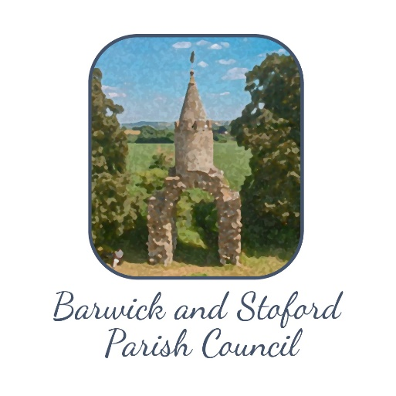
Policy adopted: 21st June 2023
Privacy Policy:
- We do not routinely acquire personal data. Almost all our business relates to matters and information in the public domain (e.g. agendas, minutes, accounts, planning applications, District, County, Unitary Somerset Council and Government communications)
- We are sent data relating to individuals when they contact us (e.g. by letter, email)
- We only use the data for the lawful purposes of the Parish Council.
- We only make the data visible or accessible to others (including in minutes) when we have specific consent. Subjects may withdraw consent at any time
- Data are stored on the clerk's dedicated laptop computer and/or in the Parish Council files held by the clerk, and these are normally deleted after 5 years.
- Councillors follow a Code of Conduct which covers their use of emails and care of documents, including the steps to be taken when they retire from the Council. It also defines special measures to be taken for confidential matters.
- We offer 'subject access' –we will tell people what data we have relating to them – free of charge, on request.

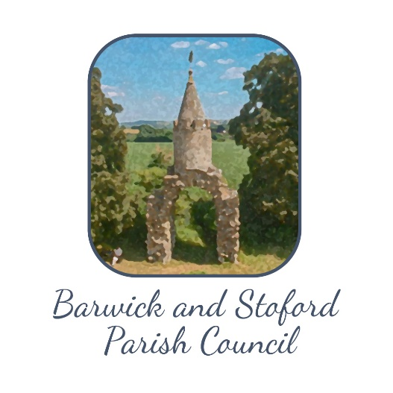
Additional wording adopted 21st June 2023
Addition to Standing Orders (as applicable to GDPR)
The Parish Council (PC) has to comply with the General Data Protection Regulation which requires that measures be taken to protect the privacy of individuals. We have a Privacy Policy. This Code explains what is required of Councillors to ensure compliance with the Policy and the GDPR.
- Use of personal data is only allowed for our ‘lawful purposes’, and only when the ‘subject’ has given specific consent.
  - The Clerk will normally secure consent
  - If you or someone else secures that consent, the Clerk must be informed
- Our PC meetings, agendas and minutes are public
  - Discussions when the public is present and public documents must not reveal personal data unless the subject has given consent
- Most communication with and between councillors is via email.
  - Councillors may use a private email address provided that access is security-protected (device and mailbox).
  - It is recommended that, after receiving attention, emails relating to PC business are either deleted or moved to a dedicated PC folder.
  - Emails containing people’s data which is not public must not be sent to others outside the PC unless the ‘subject’ has given specific permission.
  - When retiring from the PC, all related emails should be deleted.
- Councillors may occasionally come into possession of documents which have individuals’ personal data (names, addresses, emails etc).
  - Documents must not be passed or copied to others outside the PC unless the ‘subject’ has given specific permission.
  - All documents relating to PC business must be destroyed or returned to the clerk when a councillor retires.
- If the Chairman declares that a particular matter is Confidential (e.g. because it relates to a crime or a safeguarding matter), special measures are required.
  - There must be no discussion in a public meeting, and no mention in public agendas or minutes
  - Emails which include information allowing the identification of any individual concerned are forbidden, except between the Clerk and the Chairman. (Editing to replace names with ‘A, B’ etc. is allowed).
  - The Clerk and Chairman may distribute documents relating to the matter for reference in meetings, but these must be collected at the end of the meeting.

