S^{t} Mary Magdalene
Barwick & Stoford

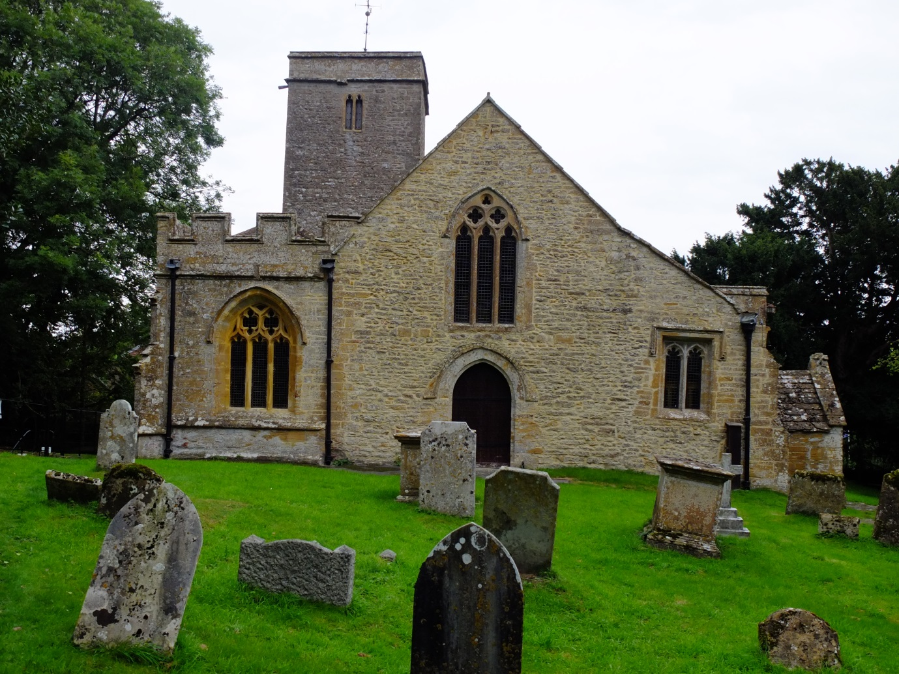
A Short History of the Grade II* Listed Church
Heritage England Listed Building 263559

The Parish church of Barwick & Stoford was built as a chapel of the Minster church in Yeovil prior to 1219.

The Church - ST 55790 13850 (ST 51 SE)
Barwick is not mentioned by name in the Domesday Survey, but in 1228 Henry III granted a fair, and in 1231 a market, both to the first William de Cantiloupe and both to be held in the parish. The third William de Cantiloupe, who held the manor of Barwick in 1251-2, founded the free borough of Stoford, and had the chapel re-classified as a church. The new town of Stoford was laid out in burgage plots which were let to free tenants, and remained part of the Barwick Manor estate.

Barwick and Stoford are in the south of the county of Somerset on the Dorset border, 1½ miles south of Yeovil. The church lies 330yds east of the Roman road from Ilchester (Lindinis) to Dorchester (Durnovaria), now the A37, with the church just outside it to the NW. It dates largely from the 13thC, and is of Hamstone roughly squared and coursed stone, with ashlar dressings. During restoration works, a hole through the west wall of the aisle, revealed a standard construction of two stone faces with mortared rubble core. It has a 2-bay chancel and a 3-bay aisled nave with a south porch. The tower is at the NE corner. The chancel was rebuilt in 1885 reusing earlier fragments. The roof is covered with plain clay tiles between coped gables to the chancel south aisle and nave, with a tiled roof to north aisle and lead roof on the tower. The south porch has stone slates.

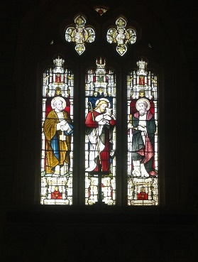
The Somerset Historic Environment Record no - 53548 describes the church as: “A small church next to a sandstone cliff of 13thC origin. It is described as perpendicular in design, un-buttressed with lancet windows and parapet. The north aisle is dated to 1489 with three-light widows, gargoyles and battlements, which was paid for by the nuns of Syon Abbey which was the Lord of the Manor and owned the parishes’ tithes. The south aisle is older and was cut through an even older wall and has single-chamfered piers and arches. The chancel interior was rebuilt as part of a major ‘re-ordering’ in 1885. The graveyard has been in use since at least medieval times.” The church is on the Heritage at Risk Register.

The south aisle was added in the late 13thC early 14thC. The west door and window were added in the 14thC.

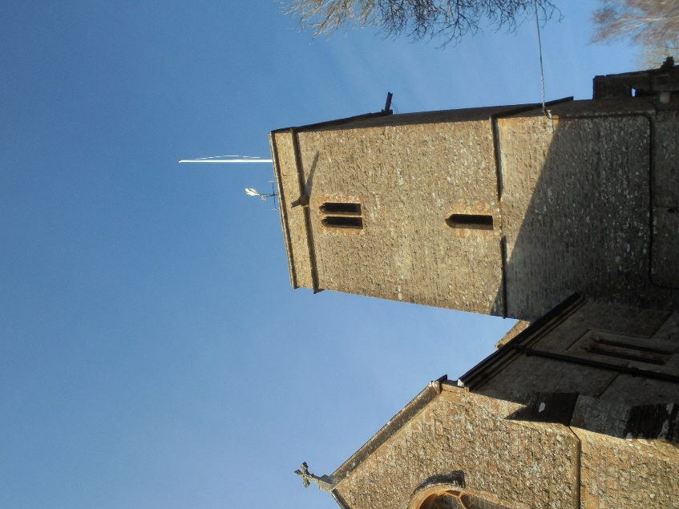
The church now is the size it was around 1500 but over the centuries has received considerable extensions. The original nave and chancel are the oldest parts of the church, and the renovated Chancel being the newest.

The Tower

Access to the tower is via an arched doorway from the chancel, made up of a sepulchral slab with incised foliated cross. The tower dates from about 1400 and is, unusually, built on the north side. It is relatively short so has no buttressing. The tower is of 2-stages marked by string courses, simple parapets and un-buttressed. The lowest stage has simple lancets in the N and E faces and simple arched doorway in the SE corner; simple lancet just above string on the E side. On the north side is a smaller 15th C window.

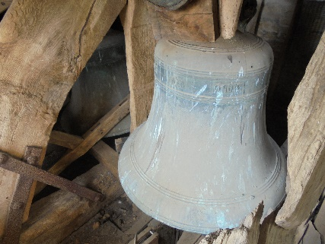
The tower houses two bells, one 30in and one 33in. Due to the unstable condition of the timber bell frame the bells were lowered onto supporting timbers (and the frame partly dismantled) as part of the tower roof restoration in 2019. The 33in bell has the Latin inscription “St Katherine prega per noi” translated says “St Katherine pray for us”

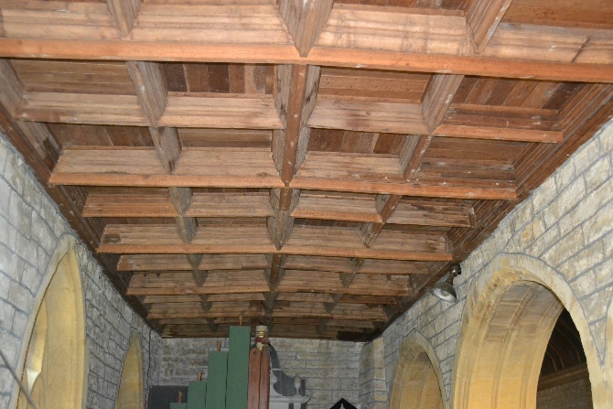
The North Aisle
In order to create the north aisle, the north wall of the original nave was taken down and the staircase to the rood loft was blocked (and probably replaced with a wooden ladder). The north aisle is beautifully designed and built, being completed in about 1489. The panelled ceiling is particularly attractive.

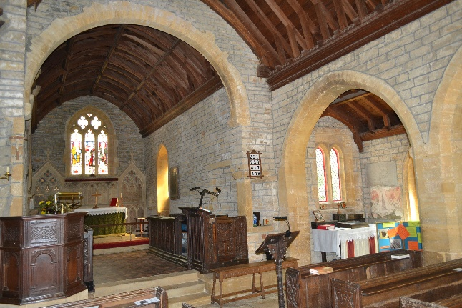
The Nave
The nave has the spectacular pew ends (see below).

The South Aisle
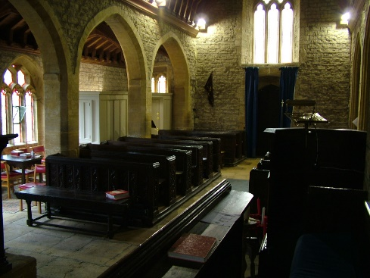
The south aisle was built at the same time, or just after, the nave was built. The floor was originally some two feet below the level of the nave, maybe to save money when originally built (as the ground slopes downwards) or maybe the south wall subsided. The floor was raised, probably during the major reordering in 1885. This made the south porch entrance unusable and the windows appear very low.

The Chancel
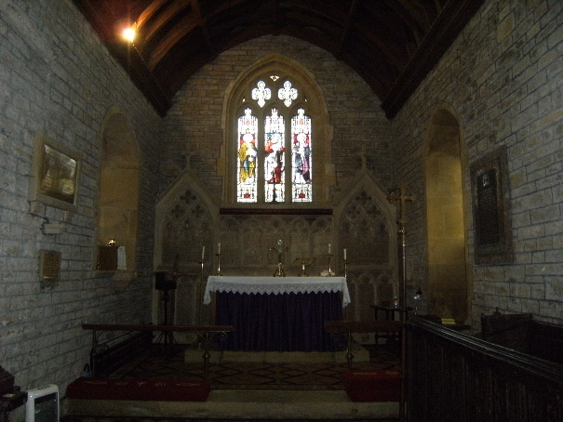
The chancel is probably built on the site of the original chapel, as it is joined to the nave by the large Norman arch. The interior of the chancel was rebuilt in 1885 when the two-light side windows were restored and the east window was restored with coloured glass. A new reredos was added with carving and colouring – the words of the Ten Commandments, the Creed and the Lord’s Prayer are picked out in warm golds and reds. The floor level was raised and floored with Victorian tiles

Font

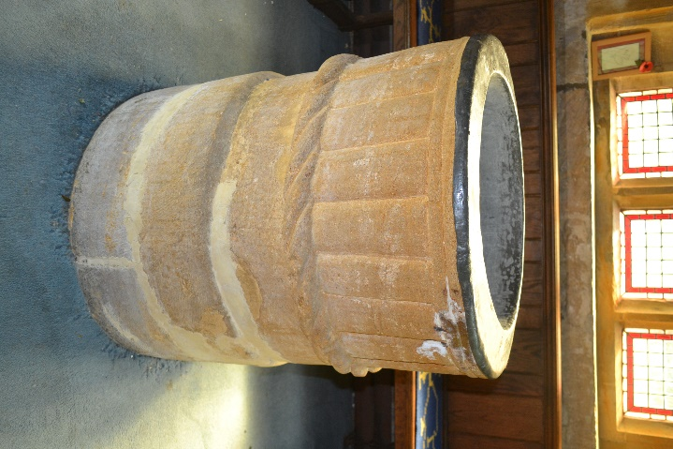
The font is the oldest part of the church. It is early 12thC and is situated on the raised floor area at the W end of the N aisle. It is formed from roughly carved Ham Stone which would have been sourced locally. It is a cylindrical fluted bowl with a double-torus upper rim measuring 25in in diameter and 9.5in deep with off centre drain hole. The bowl is lead lined and is decorated on the outside with vertical pillar on a twisted-rope/cable moulding band and stands on a cylindrical stem 5in high off a cylindrical base which is 13in high and 25in diameter. The rope motif is a typical late Saxon/early Norman decoration. The font stands 30in high and is topped with a simple circular Oak timber lid with iron cross and metal fixing studs. Its centre has a twisted wrought iron decorative feature.

Pulpit

The Jacobean carved oak paneled pulpit has the following scratched into the front panel: E.M. Rect. 1619. The pulpit was provided by the Rector at the time, the Revd. Eustace Moore in 1619. It stands on an octagonal plain dressed stone base. The carving of the timber of the pulpit is not of the same standard as that of the pew ends. It has an upper above a lower band of arched panels. The panel facing down the nave has the above inscription carved in it.

Brass Reading Stand

The brass reading stand on the pulpit has the following inscription:
“Presented to the Church of S^{t} Mary Magdalene Barwick by the Sailors and Soldiers of the Parish as a thank offering to almighty God for their safe return from the Great war 1914 – 18”

The Reading Desk

The initials W.H. on the door of the reading-desk are said to be those of William Hope, the patron of the living early in the 16th cent.

The Pews

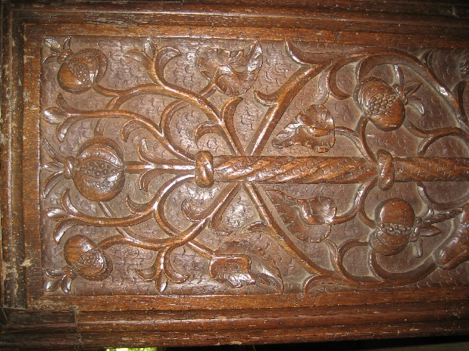
The old oak pews are in good preservation displaying some exquisite carving. There is a wonderful variety of designs and scenes from country life. There is a man with a bow and arrow shooting a bird; a fox running away with a goose chased by two dogs; dogs hunting in a warren with the rabbits taking refuge underground. There are symbolic carvings, such as a jar with lilies, the emblem of the Virgin Mary; a wise ‘Green Man’, with foliage spouting from his mouth; also there are stags and a pelican.

In the chancel the pair of pew ends show the arms of Rogers and Echyngham quarterly, impaling Courtenay and De Redvers quarterly. The two pew ends are a pair, almost alike, the only difference being that one shield, the earliest in the succession is suspended by a guige (a long strap, typically made of leather, used to hang a shield on the shoulder or neck when not in use), from a hawthorn tree in blossom, and the later one from a hawthorn tree in fruit. The Rogers arms, is that of Sir John Rogers of Bryanston, whose family owned Barwick Manor. One of the pew ends has the date 1533 carved in it; the time he served as justice of peace (J.P.) for Dorset 1528 – 1565. He was appointed High Sheriff of Somerset and Dorset between 1552 and 53. He saw armed forces service during the northern uprising in 1536, and again in 1544, when he served at the siege of Boulogne. He died in July 1565 while staying at Beck, Berkshire. He is buried in the Parish Church of Blandford Forum, Dorset.

The Piscinas

The chancel has been rebuilt, but it retains the original Piscinas. The Piscinas is a shallow basin usually placed near the altar of a church for washing the communion vessels. The sacrarium is the drain itself.

The Visitors Book

The first entry in the visitors’ book is that of The Right Revd: The Lord Bishop of Bath & Wells, who visited the church on Sunday September 29th 1929.
During the years of the Second World War, visitors included serviceman and servicewomen from as far away as Ontario in Canada, New York City, and New Jersey, Chaplain Anderson in the US Army from Minnesota in the USA, St Maj Klein of the Czech army. There were over 20 visits by service personnel who were probable based in and around Yeovil during the War. There was a small US Army HQ based in Barwick House during the war.
On the 18th October 1941, LCpl Malcolm Rabjohns of the 1st Bn The Coldstream Guards, a resident of Yeovil visited the church whilst home on leave. Sadly, he died on the 17th May 1943.

Gargoyles, Grotesques and Beasts

Gargoyles are a projecting stone figure usually carved in a grotesque manner, designed to throw rainwater away from the walls and footings of a church.
The design of the ? at St Mary Magdalene are in the shape of beast heads, but are not used as water spouts, they are purely decorative.

The South Porch

The south porch originally was the entrance to the church. It was rebuilt due to settlement. When the floor in the south aisle was raised, the porch was no longer useable as the entrance, and was turned into a store.

Rood-Loft Stairs

The remains of the stone stairs that once led up to a rood loft can be found behind the pulpit. The rood screen would have been hung below the chancel arch and would have held the crucifix (Rood) in the centre of the arch. Timber rood screens had a wainscot base, the panels of which corresponded with the openings above. The wainscot panelling would probably have had small perforations or peep holes which would have assisted standing parishioners and children a view of the Chancel and alter.
The rood loft was a means of access to the Rood and would have been about 6ft deep, and projecting in front and behind the screen. Some lofts had an alter with a Piscinas high up in the wall.
Rood-lofts became general in parish churches during the second half of the 15C, with the screen being richly coloured and gilded.
It is probable that the Rood screen and loft had been removed by the time of the Order of 1561 in Elizabeth’s reign when many were removed and pews were provided. This is reinforced by the date on one of the pew ends 1533.

Mass Dials (Scratch Dials)

Located on the south wall of the church, this form of sundial was used to mark the ‘variable’ time of liturgical services in the medieval world. There are 2 dials evident.
Generally, Mass Dials consisted of a simple indicator – a short wooden peg or ‘gnomon’ projecting at right angles from a hole in the south wall of a church to cast the sun’s shadow – and a series of scratched or carved lines radiating from the centre point, which the shadow traversed. They were in use from pre-Conquest days until the Reformation, and were to show the hour at which Mass would be celebrated in the church.

Consecration Crosses

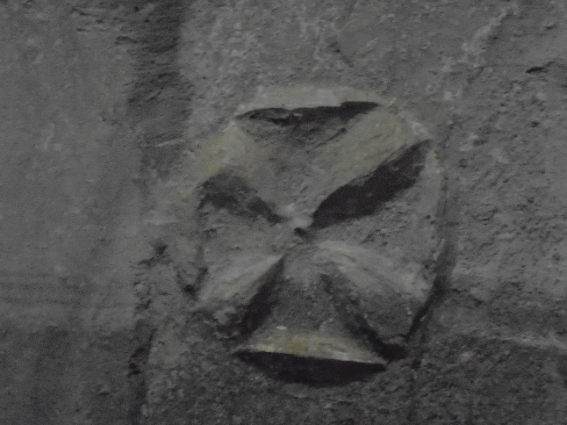
The crosses here at St Mary Magdalene are carved in the stonework around the outside and inside of the church. There are 8 evident outside, and 1internally. These stylised crosses were anointed with oil as part of the ceremony officially consecrating the church. The crosses have equal length arms to distinguish them from the main crosses of the church, which would typically have longer stems.
In this case, the fact that there are both internal and external examples indicate that it was done according to the English Rite and not that of Rome, which only required consecration on the inside.
Consecration Crosses also called Rounded Crosses are a geometric cross shape, usually enclosed within a circle, painted on interior and/or exterior walls of medieval churches and sometimes on the altar itself. Consecration crosses were a lasting reminder of the sacred purpose to which a church building was dedicated.
During the Middle Ages, it was common to incise twenty-four into a church, three on each internal wall and twelve outside each cross representing one of the twelve apostles. The bishop who consecrated the building would anoint each one with the words ‘Sanctifecetur hoc templum’ (blessed be this church). This was a visible sign of dedication and a defence against the powers of the Devil.

Compiled by Derek Pearce, Victoria Garratt and Chris Story
October 2021

